Name : Chetan Rajesh Kabra

Student id : 1001152872

Name : Suyog Swami

Student id : 1001119101

We have created an app similar to google Map :

Where user can get route from source to destination and we have used d3.js ,leaflet.js and mapbox.js

for visualization .

Used googlemaps direction api for finding best available direction from source to destination.

Below are the http address to access the app:

<http://52.11.30.186:5000/>

Dynamically you can zoom in and zoom out the map .

Done autoscaling using Aws .

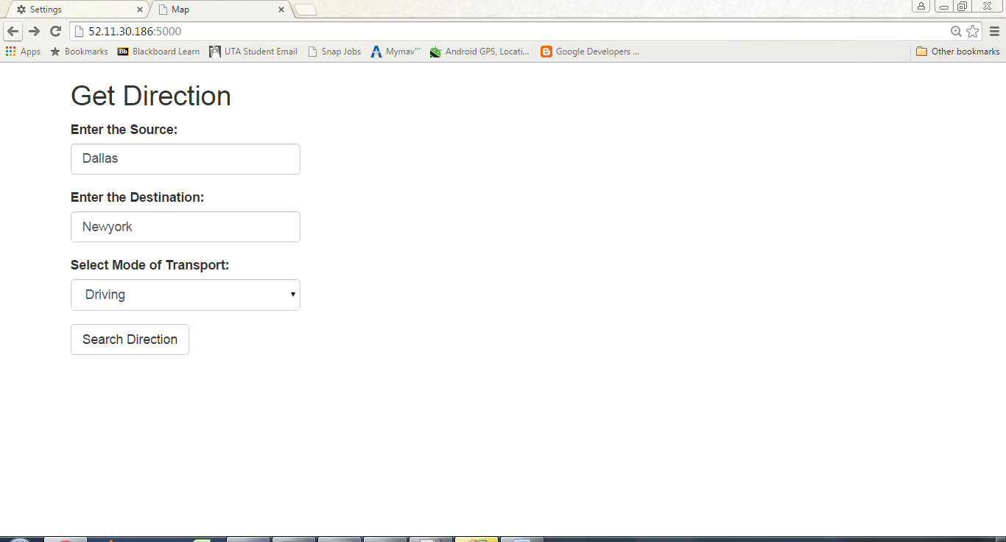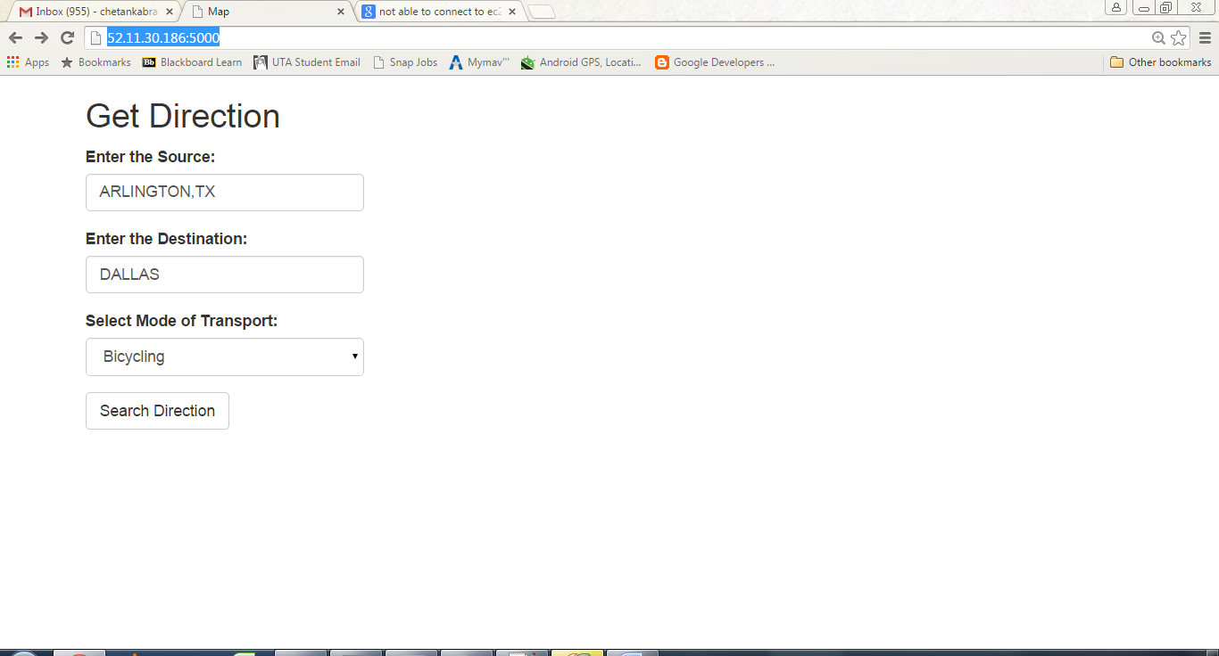

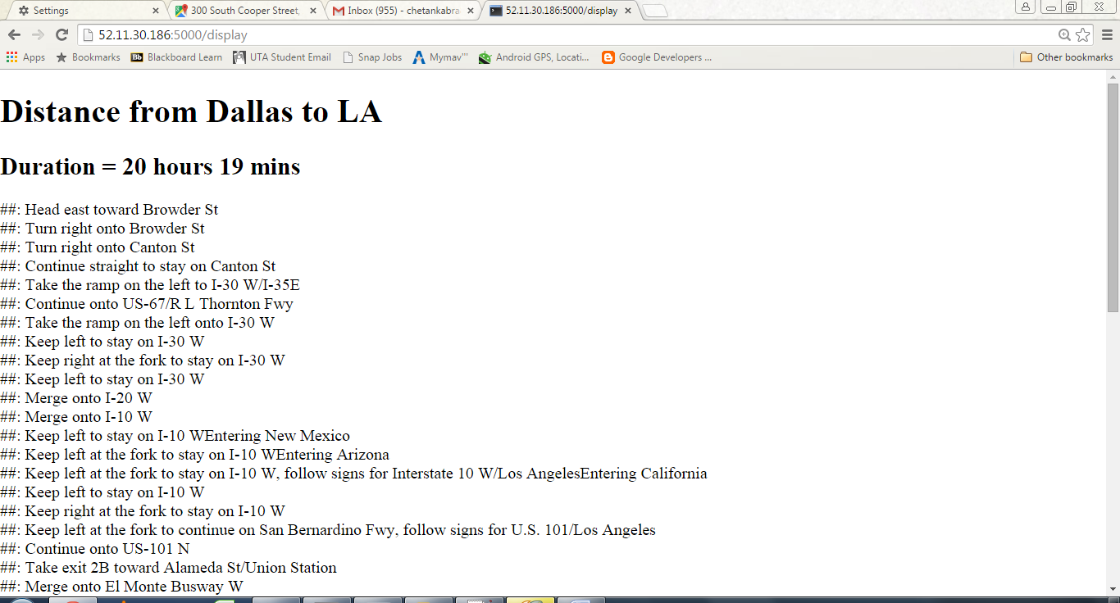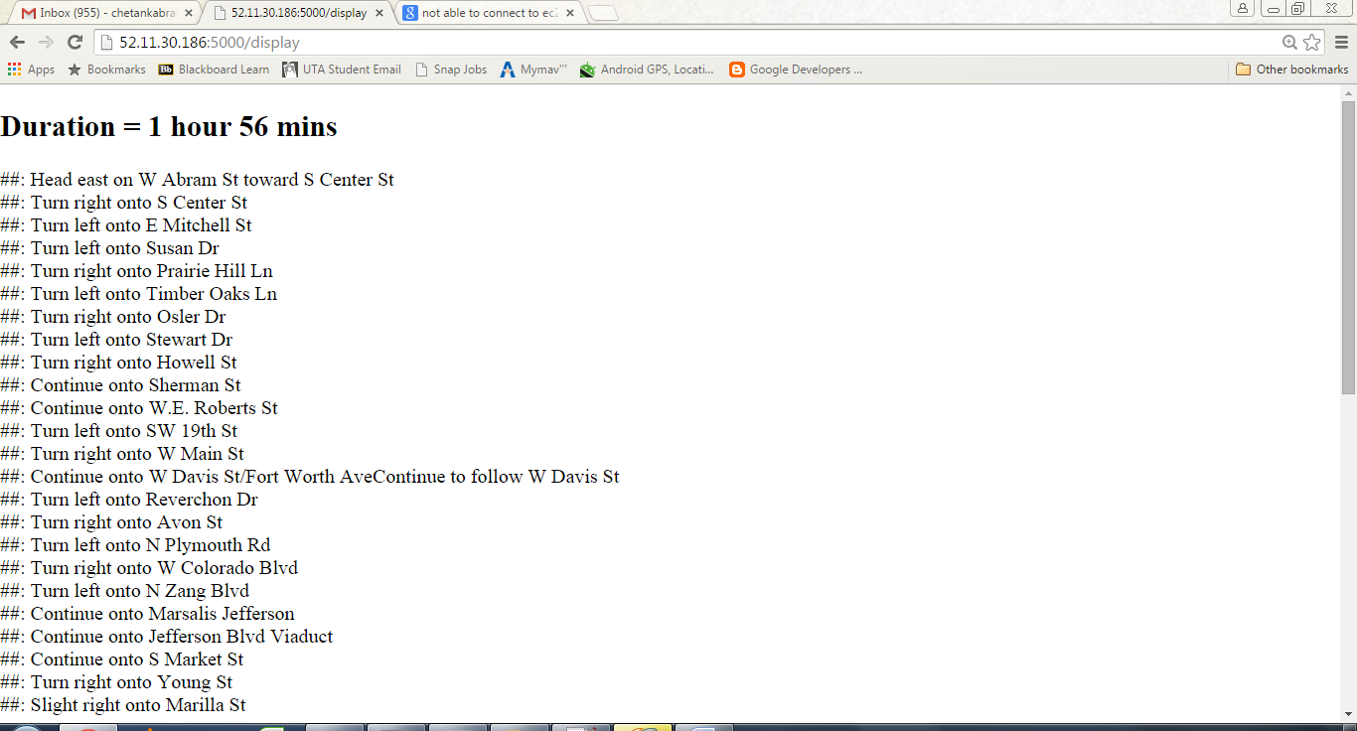

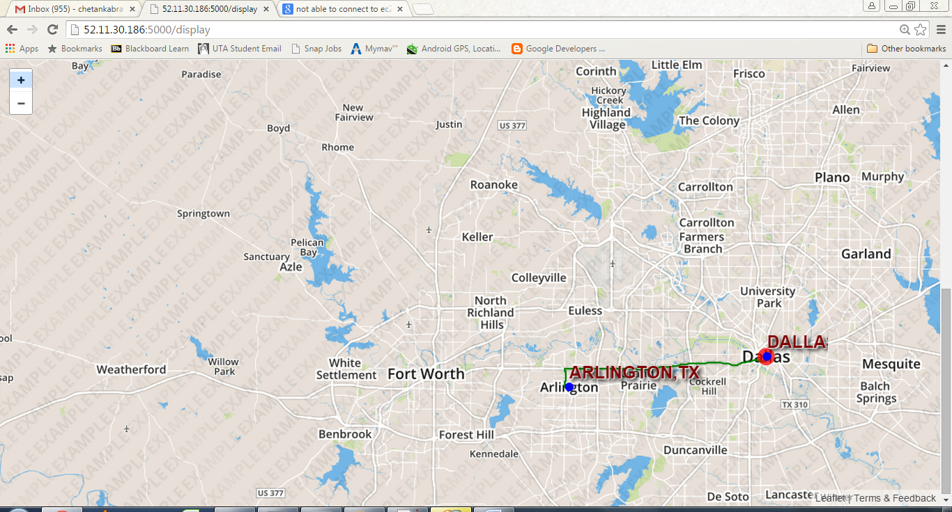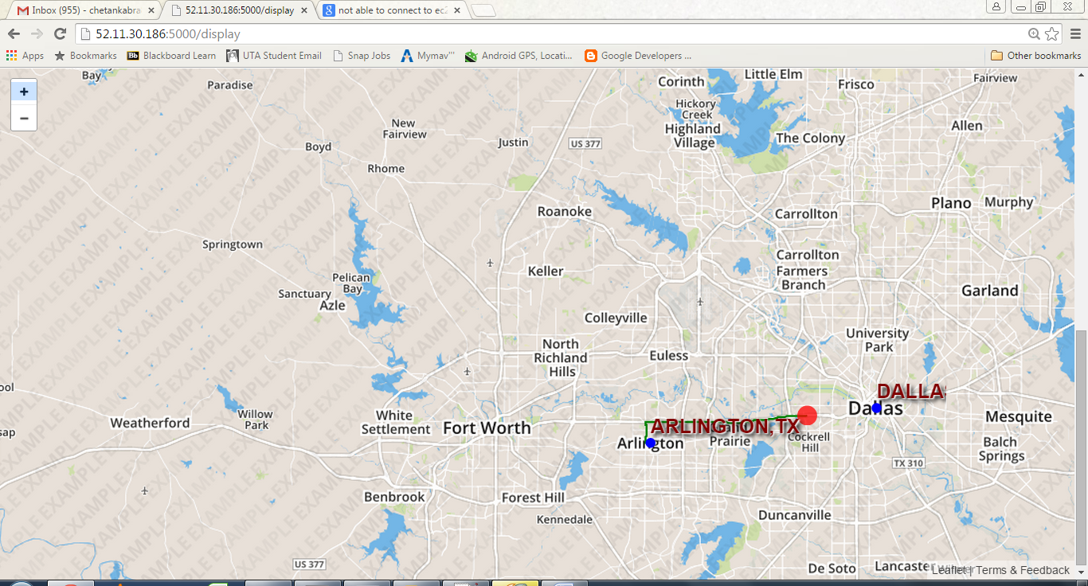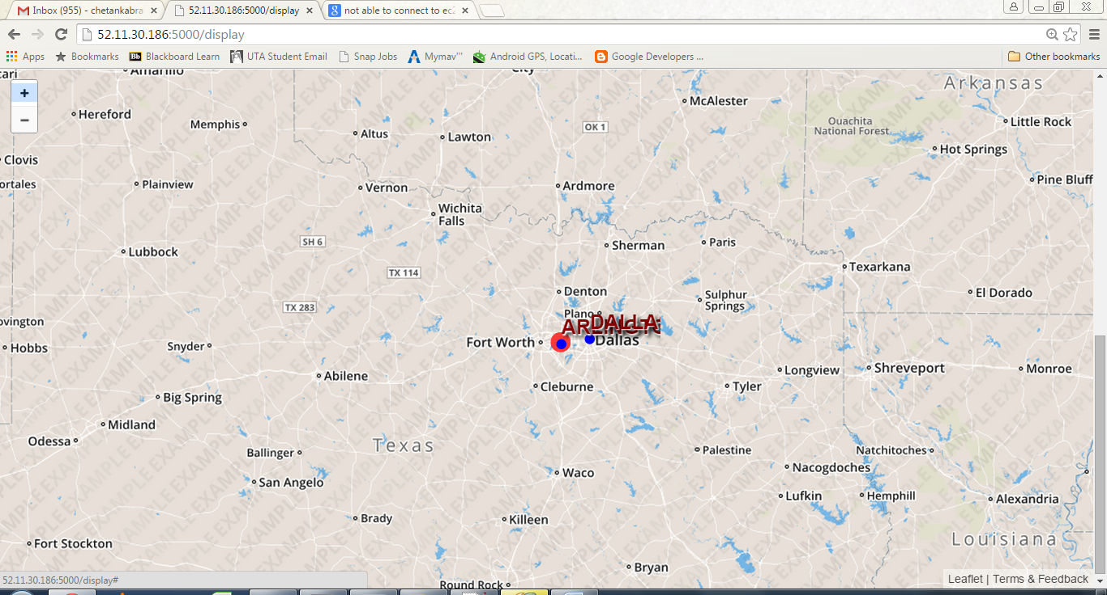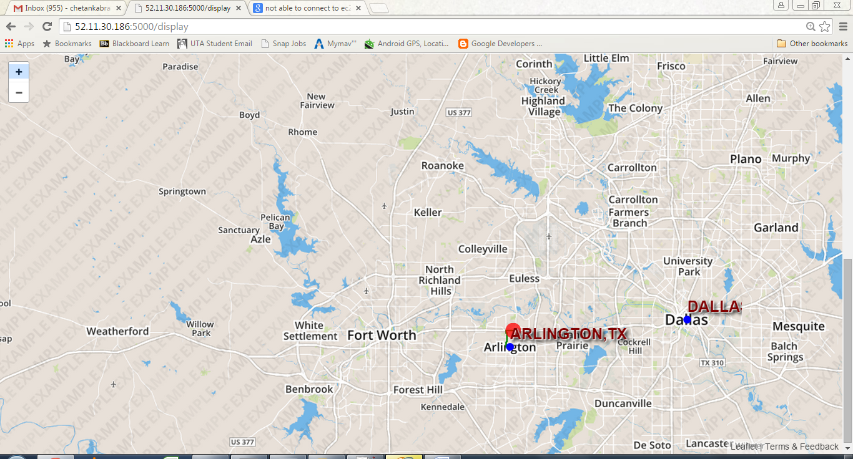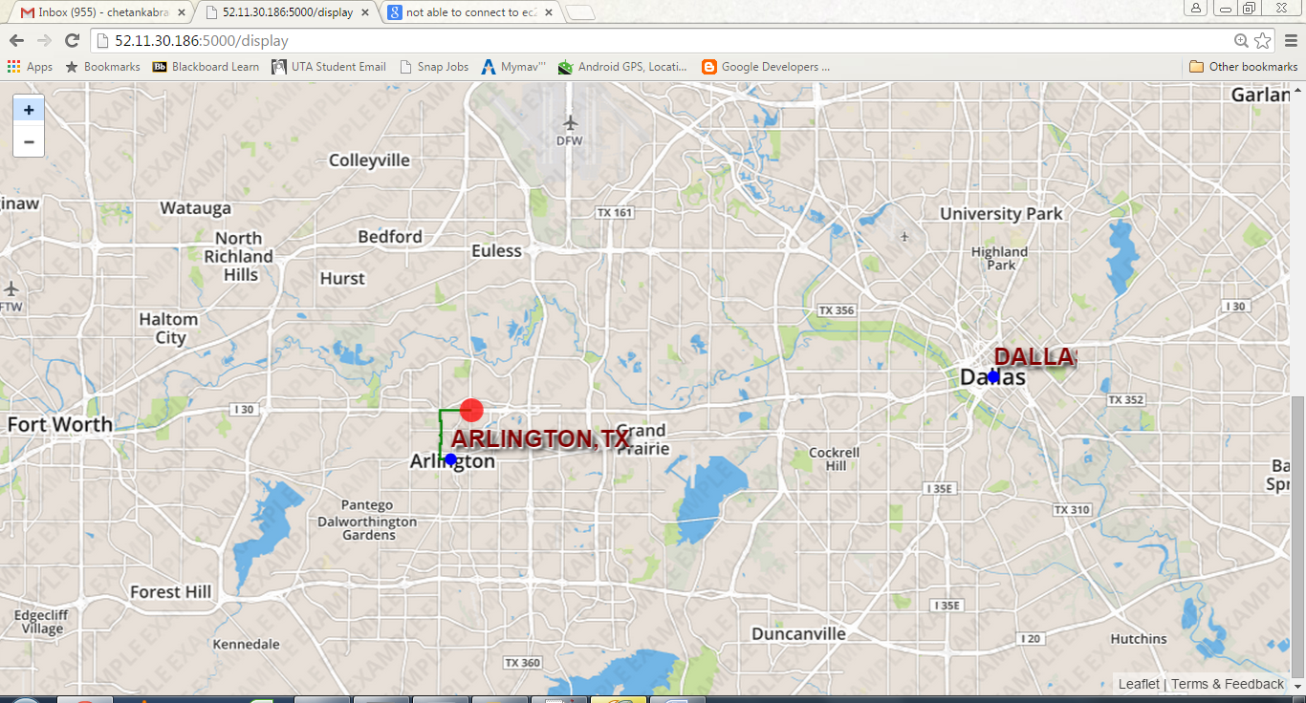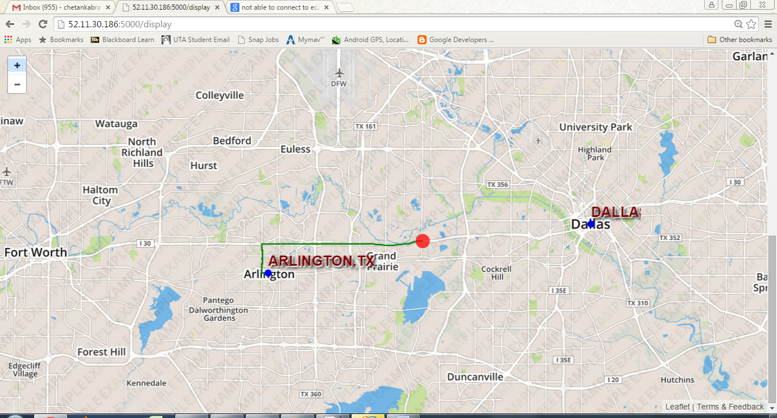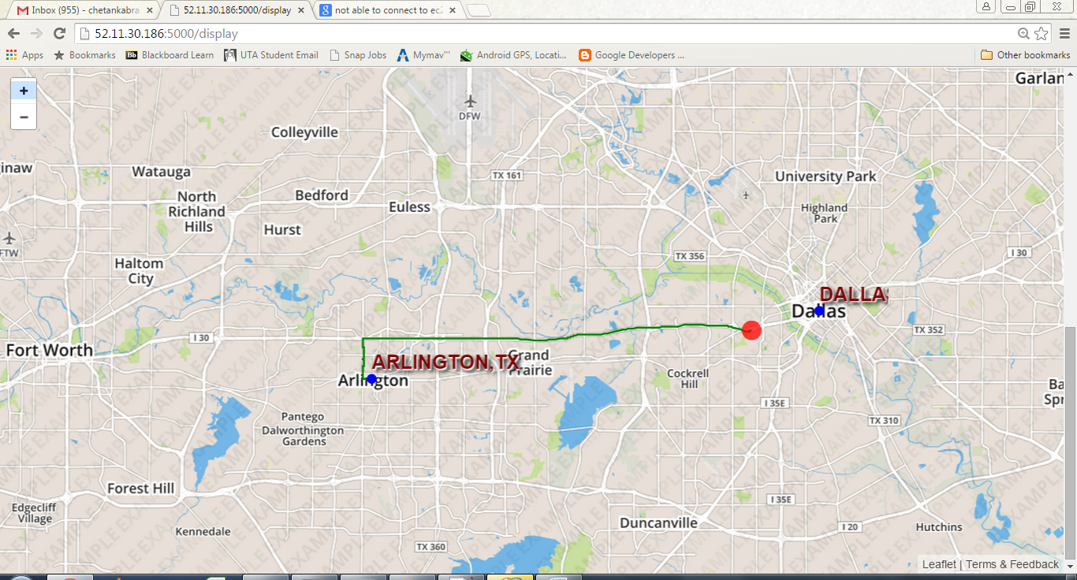

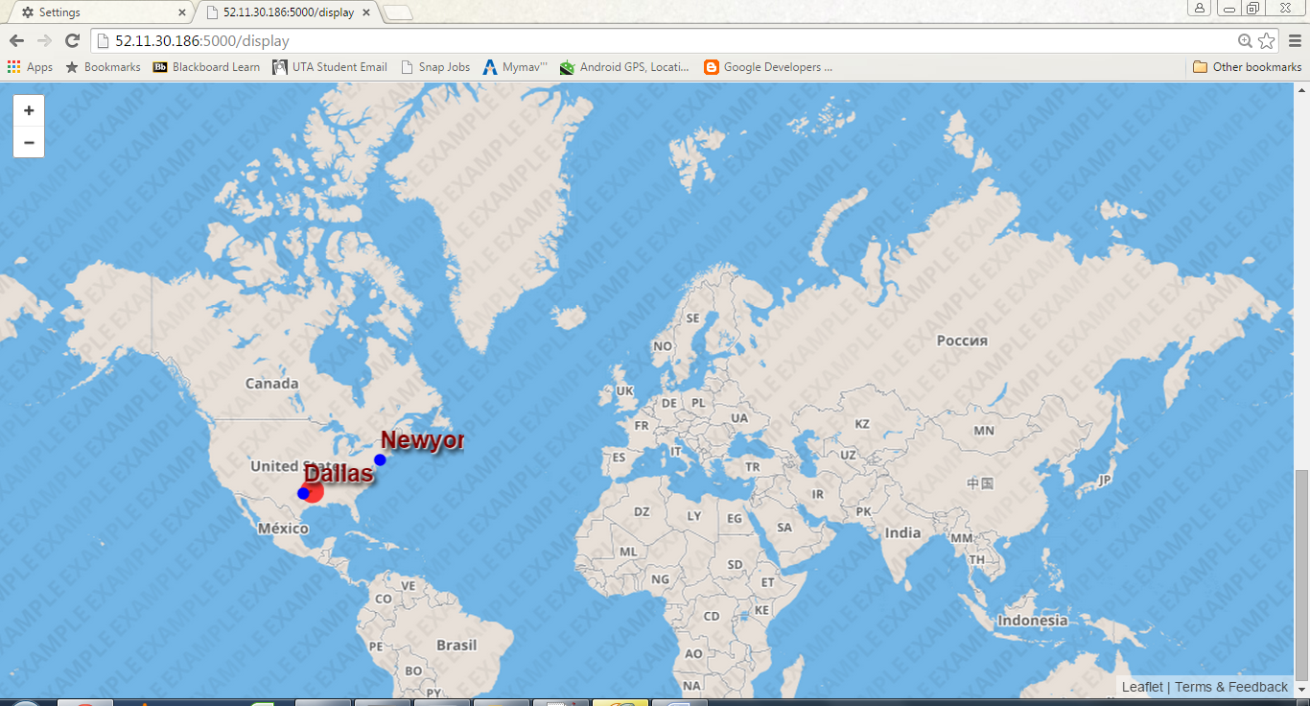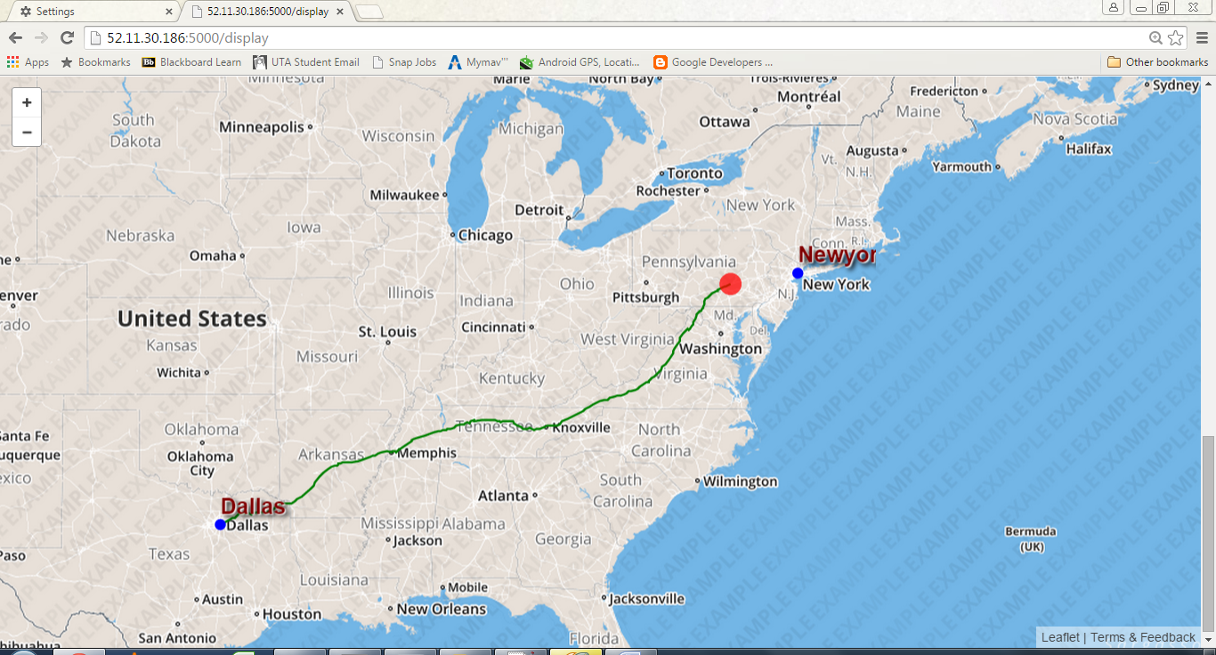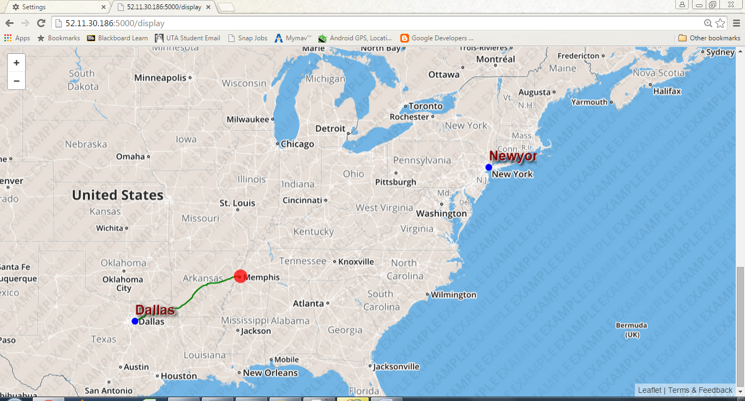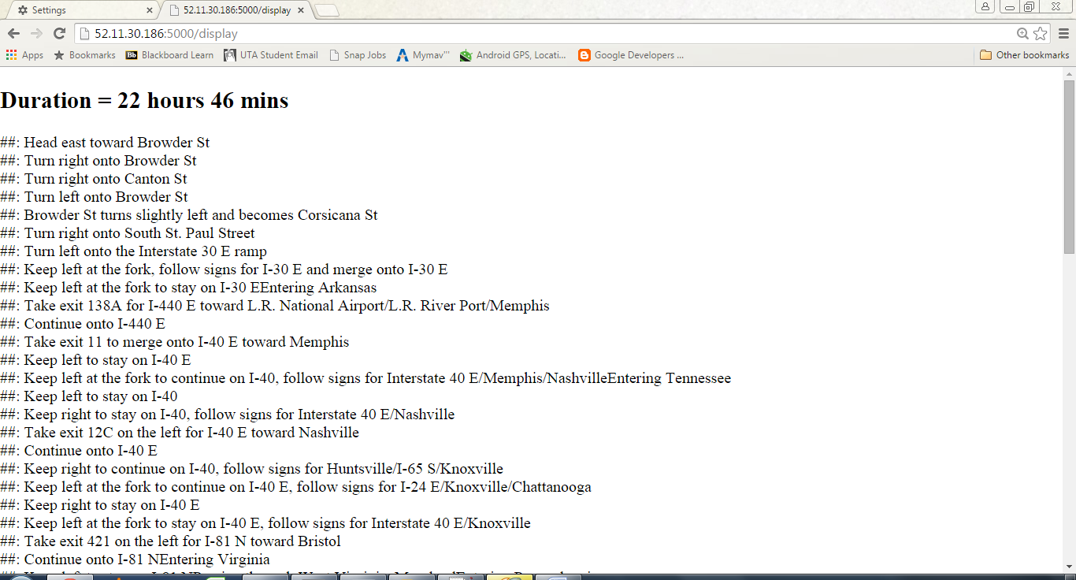

References:

[http://bl.ocks.org/zross/6a31f4ef9e778d94c204](http://www.google.com/url?q=http%3A%2F%2Fbl.ocks.org%2Fzross%2F6a31f4ef9e778d94c204&sa=D&sntz=1&usg=AFQjCNE4HLab-6wQxomIjqQCktWU4oFpfw)

[http://zevross.com/blog/2014/09/30/use-the-amazing-d3-library-to-animate-a-path-on-a-leaflet-map/](http://www.google.com/url?q=http%3A%2F%2Fzevross.com%2Fblog%2F2014%2F09%2F30%2Fuse-the-amazing-d3-library-to-animate-a-path-on-a-leaflet-map%2F&sa=D&sntz=1&usg=AFQjCNErVF7U3iZNsF_KPPLsYaQdfj5d3Q)

[http://zevross.com/blog/2014/09/23/convert-google-directions-to-geojson-points-or-polylines/](http://www.google.com/url?q=http%3A%2F%2Fzevross.com%2Fblog%2F2014%2F09%2F23%2Fconvert-google-directions-to-geojson-points-or-polylines%2F&sa=D&sntz=1&usg=AFQjCNFVo_c4mw7eeGDIZrax6HyzrGIXCw)

[http://www.andrewdyck.com/how-to-convert-csv-data-to-geojson/](http://www.google.com/url?q=http%3A%2F%2Fwww.andrewdyck.com%2Fhow-to-convert-csv-data-to-geojson%2F&sa=D&sntz=1&usg=AFQjCNGMjvuN9noOTPuQN-vLX2vqsEMG5Q)

[http://seewah.blogspot.com/2009/11/gpolyline-decoding-in-python.html](http://www.google.com/url?q=http%3A%2F%2Fseewah.blogspot.com%2F2009%2F11%2Fgpolyline-decoding-in-python.html&sa=D&sntz=1&usg=AFQjCNFJwzl_YplcTJwL5kJColAh0YXFOQ)

